Sales Order Type Mandatory Pre-Posting – CRIM 0397

|  |  |  |  |  |
| --- | --- | --- | --- | --- |
| **Ver** | **Date** | **Author** | **Comments** | **Reviewed by** |
| 1 | 01/12/2020 | Tom Bell | CRIM 0397 | TBC |
|  |  |  |  |  |

Requirements 2

Prerequisites 2

Solution Overview 2

Solution Details 2

Security 3

Companies 3

Data Migration 3

Test Steps 3

Technical Implementation 3

Requirements

The system must make Pre-Postings Mandatory depending on the Sales Order Type.

Prerequisites

<Describe any pre-requisites that this development may rely upon, data configuration or other developments>

Solution Overview

Six tick boxes are required on the Sales Basic Data - Order Type Tab. Depending on what tick boxes are checked will determine what/if Pre-Posting data is mandatory for a particular Order Type. When a user goes to change the status of the Sales Order to Released, an event will take place to check that the ticked check boxes have Pre-Posting data in either the Order Header or all of the Order Lines. If there is no Pre-Posting data for any checked fields on the Order Type basic data screen then the Order cannot be released.

**Logic Overview**

**The Order Pre-Posting Check will take place if the following criteria is met:**

* “Mandatory Pre-Posting” check box is ticked, and additional Code Part Values (tick boxes) are checked.

**If the above condition is true, upon trying to change an Order Status to released. An event will take place that checks for one or more of the following conditions.**

* Header Level Pre-Posting field(s) have been populated for the checked Code Part Values.
* All Line Level Pre-Posting field(s) have been populated (All Lines need Pre-Posting data if Header Pre-Posting is not populated).

If there are required Pre-Posting data that have not been complete then the system will display an error message, detailing that Pre-Posting data is required in either one (or more) Order Lines or Order Header.

Solution Details

In the Order Types basic data screen, a check box is needed called “Mandatory Pre-Posting data”. This check box will determine if the Order Type will allow an Order to be released with or without Pre-Posting data defined.

If this check box is selected then the system will make the following check boxes available for editing

* **B – Proposition**
* **C – Project**
* **D – Site**
* **E – Cost Centre**
* **F – Contract**
* **F – Code G**

The below screenshot shows where the check boxes should appear.

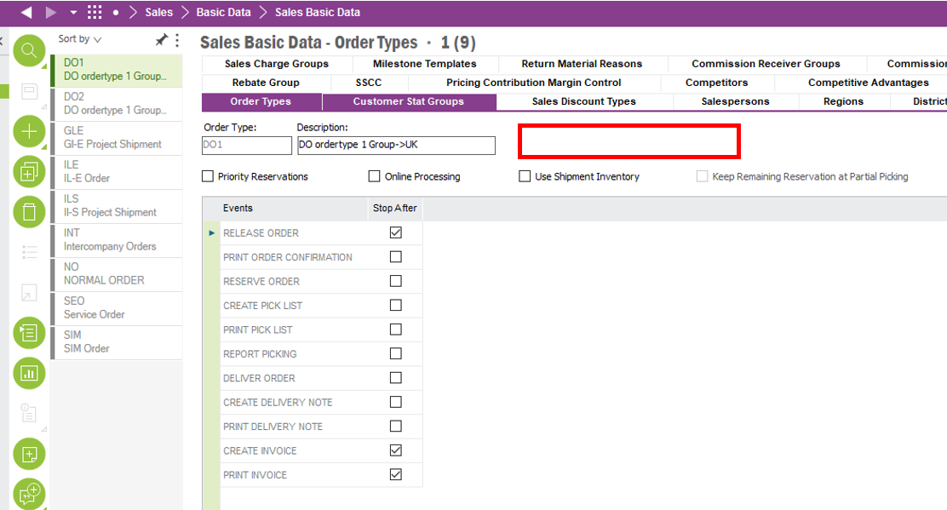

The below screenshot shows the check boxes that are required. In this below example, Mandatory Pre-Posting has been enabled for Prop, Project, Site, Contract and Code G. This means that Pre-Posting (on either the Header or Line Level) needs to be is mandatory for those fields only.

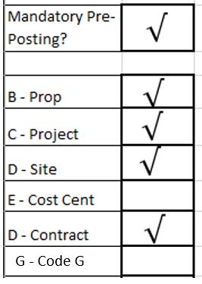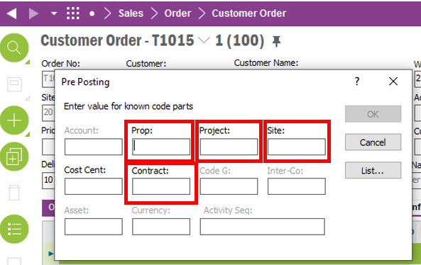

Technical.

Field Definitions.

<New Field/CLU Definition>

|  |  |  |  |  |  |  |
| --- | --- | --- | --- | --- | --- | --- |
| New DB Object Name | DB Object Item/Field Names | Item Description | Item Data Type | Item Syntax | Calculation Spec, if Derived | LOVs/Enums/Is Mandatory? |
|  |  |  |  |  |  |  |
|  |  |  |  |  |  |  |
|  |  |  |  |  |  |  |
|  |  |  |  |  |  |  |
|  |  |  |  |  |  |  |
|  |  |  |  |  |  |  |
|  |  |  |  |  |  |  |
|  |  |  |  |  |  |  |
|  |  |  |  |  |  |  |
|  |  |  |  |  |  |  |
|  |  |  |  |  |  |  |
|  |  |  |  |  |  |  |

Security

<Define security controls> (Who needs access to this and will it be restricted from any other users etc)

Companies

Applies to the following companies. All.

|  |  |
| --- | --- |
| **Company** | **Required (Y/N)** |
| 1201 | Y |
| TBC |  |
|  |  |

Data Migration

<Describe any data migration impacts this development may have – i.e additional data to be migrated>

Test Steps

<Steps that needs to be taken to test this change. Please provide expected results> Updated post solution.

|  |  |  |
| --- | --- | --- |
| **No** | **Script\Test Steps** | **Expected Result** |
| 1 | Go into Sales Basic Data order Type screen | See “Mandatory Pre-Posting” check boxes for Code Parts |
| 2 | Go to release an order with fields populated in order header pre posting data. | System will error when trying to set the order system to released. |
| 3 | Go to release an order with fields populated in order line. | System will error if there are no order lines with pre posting fields. However, if one or more order lines doesn’t have a pre posting contract then the system will error and not move the order to released. |

Technical Implementation

<Completed by the technical developer - Technical solution, list packages, functions, Custom menus created etc >

Delivery Notes

* Package - EA_FINANCE
* **Permission Grants applied – IFS_ALL**
* **Custom Fields**

* The fields need to be added to layout via RMB, Properties, Layout, select field and move to required location.

**Note: - If the custom fields are not available, make sure the logical unit is published and synchronized with the fields published and approved as follows. Then reload the Sales Basic Data window and add the custom fields.**

* **Events**

